**Software Requirements Specification for Kids Learning App**

**1. Introduction**

In the rapidly evolving digital age, educational tools for children have become more interactive, engaging, and technologically advanced. Kids Learning applications are designed to harness the power of technology to make education enjoyable, effective, and accessible for children aged 3 to 10 years. These applications serve as a bridge between traditional learning methods and the digital world, providing a dynamic and immersive educational experience.

**1.1 Purpose**

The purpose of this document is to provide a detailed description of the requirements for the Kids Learning application. This document will outline the features and functionalities expected from the application.

**1.2 Scope**

The Kids Learning app is designed to provide an interactive and educational platform for children aged 3 to 10 years. The application aims to engage kids in various learning activities through games, quizzes, and interactive lessons.

**2. Overall Description**

**2.1 Product Perspective**

The Kids Learning app will be a standalone application, accessible on iOS and Android platforms. It will include features that cater to different age groups, promoting learning through play.

**2.2 User Classes and Characteristics**

• Children (aged 3-10): End-users who will interact with the application, engage in learning activities, and play educational games.

• Parents/Guardians: Responsible for setting up accounts, monitoring progress, and managing app settings.

**2.3 Operating Environment**

The application will be compatible with iOS and Android devices, ensuring a seamless user experience on smartphones and tablets.

**2.4 Design and Implementation Constraints**

The app will adhere to child safety and privacy regulations, with age-appropriate content. The design will be intuitive and easy to navigate for young children.

**3. Specific Requirements**

**3.1 Functional Requirements**

**3.1.1 User Registration**

• Description: Parents can create accounts for their children, providing necessary information.

• Priority: High

**3.1.2 Age-Appropriate Content**

• Description: The app will provide content suitable for specific age groups.

• Priority: High

**3.1.3 Educational Games**

• Description: Various interactive games will be available to enhance learning in areas such as math, language, and problem-solving.

• Priority: Medium

**3.1.4 Progress Tracking**

• Description: Parents can monitor their child's progress, including completed activities and achievements.

• Priority: Medium

**3.1.5 User Authentication**

• Description: Secure authentication mechanisms to ensure child safety and prevent unauthorized access.

• Priority: High

**3.1.6 Feedback and Rewards**

• Description: Positive feedback and rewards for completing educational activities to motivate children.

• Priority: Medium

**3.2 Non-functional Requirements**

3.2.1 Performance

• Description: The app should respond to user interactions within 1 second.

• Priority: High

3.2.2 Security

• Description: Secure storage of user data and adherence to child privacy laws.

• Priority: High

3.2.3 Usability

• Description: The app should have an intuitive interface suitable for young children.

• Priority: High

**4. External Interface Requirements**

4.1 User Interfaces

• The user interface should be colorful, engaging, and easy for children to navigate.

4.2 Hardware Interfaces

• The app should be compatible with standard smartphone and tablet hardware.

4.3 Software Interfaces

• The app will use platform-specific APIs for authentication and data storage.

**5. Other Requirements**

5.1 Legal Requirements

• The app must comply with relevant child protection and privacy laws.

5.2 Documentation

• Comprehensive user guides for parents and simple tutorials for children.

**Experiment-3**

In the context of a Kids Learning app, we can identify several entities, their relationships, and related attributes while considering normalization rules. Here are some entities and their potential relationships:

Entities:

**1. User**

• Attributes:

• UserID (Primary Key)

• Username

• Password

• Email

• Age

• GradeLevel

• Relationships:

• Belongs to a User (One-to-One with User)

**3. LearningActivity**

• Attributes:

• ActivityID (Primary Key)

• ActivityName

• Description

• DifficultyLevel

• Type (e.g., Game, Quiz, Lesson)

**4. CompletedActivity**

• Attributes:

• CompletionID (Primary Key)

• ActivityID (Foreign Key referencing LearningActivity)

• CompletionDate

• Score

**Relationships:**

• A user (parent) can have multiple child profiles, but each child profile belongs to only one user:

• A child can complete multiple learning activities, but each completed activity is associated with only one child.

• LearningActivity - CompletedActivity (Many-to-Many):

• Many children can complete the same learning activity, and a child can complete multiple activities.

**Attributes for Normalization**:

• First Normal Form (1NF):

• All attributes are atomic (no multivalued attributes).

• Each attribute contains only one piece of information.

• Example: Email in the User entity.

• Second Normal Form (2NF):

• No partial dependencies of any column on the primary key.

Normalization helps to reduce data redundancy and ensures data integrity. Keep in mind that these are suggested entities, relationships, and attributes, and you may need to tailor them based on the specific features and requirements of your Kids Learning app. Always consult with stakeholders and consider the actual usage scenarios for a more accurate design.

**Experiment-4**

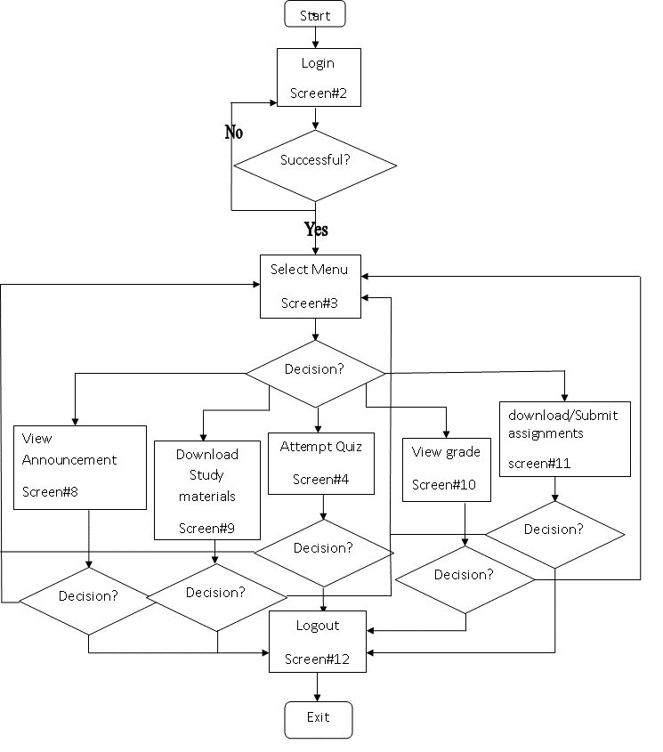

**Experiment -5**

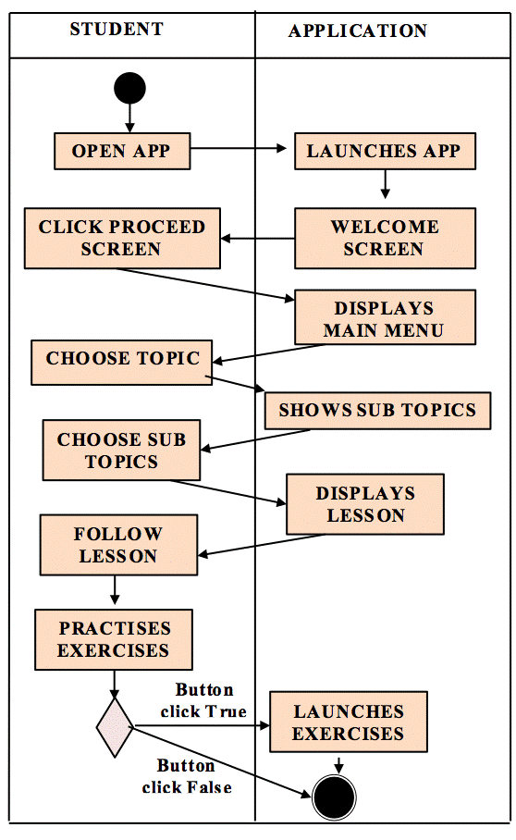

**Experiment-6**

